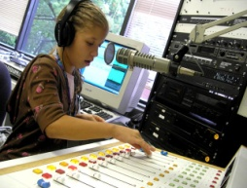
KHOI FM is an exciting project bringing local community-based radio to Central Iowa.
KHOI’s MISSION is building community through communication.
KHOI’s VISION is welcoming all voices of our community regardless of their perspectives, to freely discuss, nourish the spirit, and entertain. Our doors are open to welcome participation from all community members.
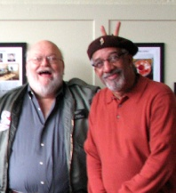
YES! I WILL BE A KHOI FUNDER!

I will give___$250 ___$500 ___$1000 Other________
Credit card: Please use Paypal at www.khoifm.org
Please make all checks payable to KHOI Radio, 410 Douglas, Ames, Iowa 50010

NAME: ___________________________________________
(Please print name)
MAILING ADDRESS: ____________________________________________ Street address
City________________state_______zip____________

EMAIL: ______________________________________
PHONE: ( ) _________________________________
______ You may recognize me by name publically
______ I would like this gift to remain anonymous.
______ Please keep me updated on progress and events _____ I am considering a major gift, please call me.
For more information, please call KHOI Phone 292-2878 KHOI or send us an email khoiradio@gmail.com
KHOI is a registered, tax-exempt organization and all gifts are tax-deductible.
KHOI FM is an exciting project bringing local community-based radio to Central Iowa.
KHOI’s MISSION is building community through communication.
KHOI’s VISION is welcoming all voices of our community regardless of their perspectives, to freely discuss, nourish the spirit, and entertain. Our doors are open to welcome participation from all community members.
YES! I WILL BE A KHOI FUNDER!

I will give___$250 ___$500 ___$1000 Other________
Credit card: Please use Paypal at www.khoifm.org
Please make all checks payable to KHOI Radio, 410 Douglas, Ames, Iowa 50010

NAME: ___________________________________________
(Please print name)
MAILING ADDRESS: ____________________________________________ Street address
City________________state_______zip____________

EMAIL: ______________________________________
PHONE: ( ) _________________________________
______ You may recognize me by name publically
______ I would like this gift to remain anonymous.
______ Please keep me updated on progress and events _____ I am considering a major gift, please call me.
For more information, please call KHOI Phone 292-2878 KHOI or send us an email khoiradio@gmail.com
KHOI is a registered, tax-exempt organization and all gifts are tax-deductible.

